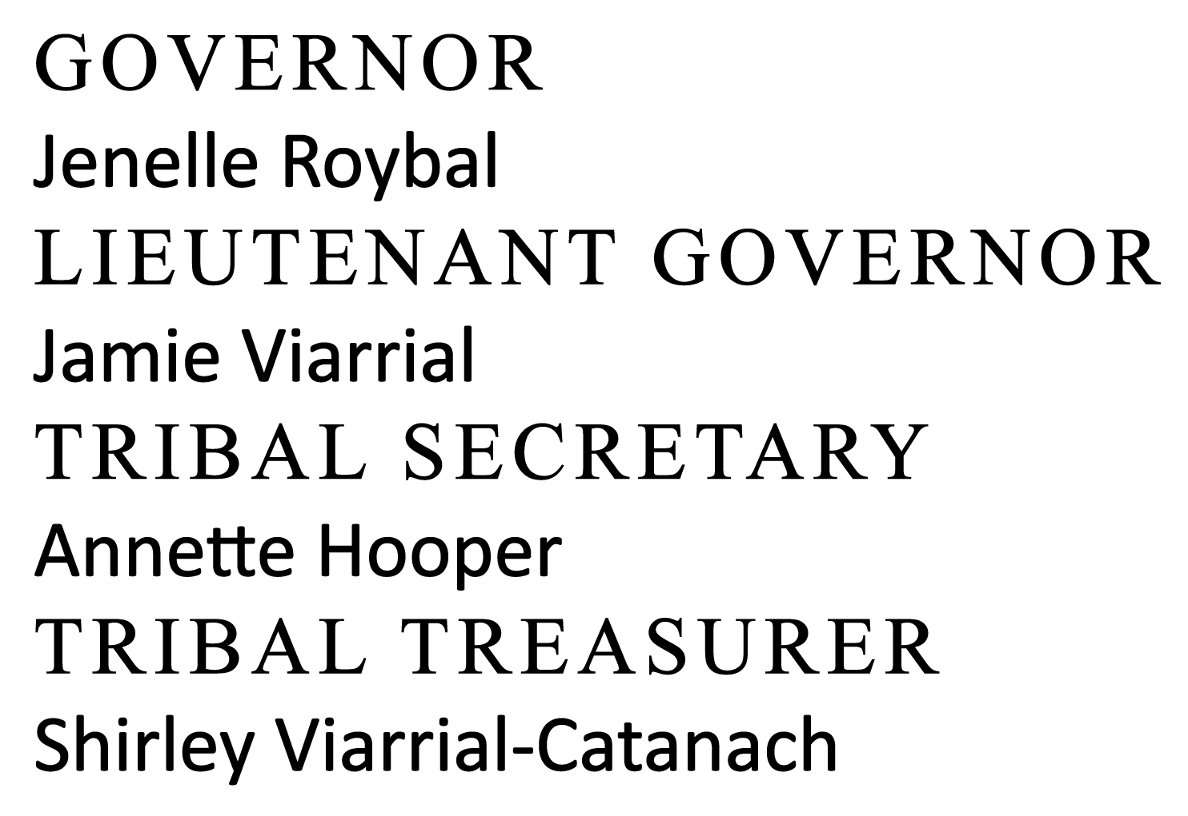
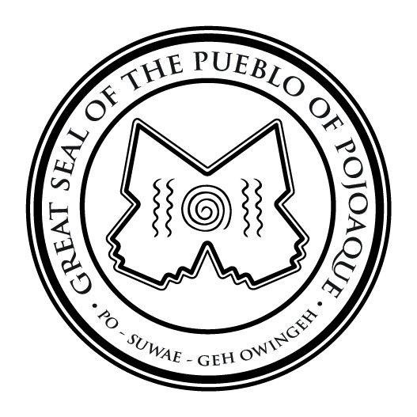
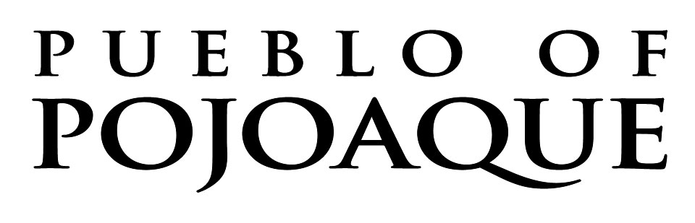

OFFICE OF THE GOVERNOR
78 CITIES OF GOLD ROAD
SANTA FE, NEW MEXICO 87506
(505) 455-3331 FAX (505) 455-3684

APPLICATION PROCESS FOR NON-TRIBAL MEMBERS
TO RESIDE ON THE PUEBLO

This process must be completed each year by the Sponsor and Sponsee. * Non-Tribal Members are not allowed to reside on the Pueblo until approval has been granted by the Tribal Council. The only exception are individuals who are married to a Tribal Member who must only complete the process once, all non-Member residents (“Sponsee”) must reapply annually.

STEP 1: Letter of Request to the Tribal Secretary’s Office. [To be filled out by Tribal Member Sponsor]
(a) Please include your name, address, phone number, and the names of everyone that is going to reside on the Pueblo with you or as your tenants.
(b) Send your completed application request to the Tribal Secretary via email or a hard copy to the Office of the Secretary.

STEP 2: Sponsee will provide the following forms, to be filled out by the applicant(s):
(a) “Request to Reside on the Pueblo of Pojoaque”
(b) “Authorization for Background Check” (for all applicants who are18 years of age or older)
(c) “Authorization for Release of Information”
(d) First time applicants must include a check or money order (non-refundable) for $53.50, made out to the Pueblo of Pojoaque. (The $53.50 covers New Mexico only. If the individual resided in another state, the cost may be more.) This fee is not required for renewal applications.
(e) Photocopy of applicant’s valid driver’s license or ID.
(f) Return the original documents to the Tribal Secretary.

*Resolution 2020-074 passed on July 16, 2020, titled “Approval of Amendment to Non-Tribal Member Resident Policy Adopted on July 16, 2020.”

If you have any questions, you may contact me at 505.228.0077 or via email or ahooper@pojoaque.org Thank you!

